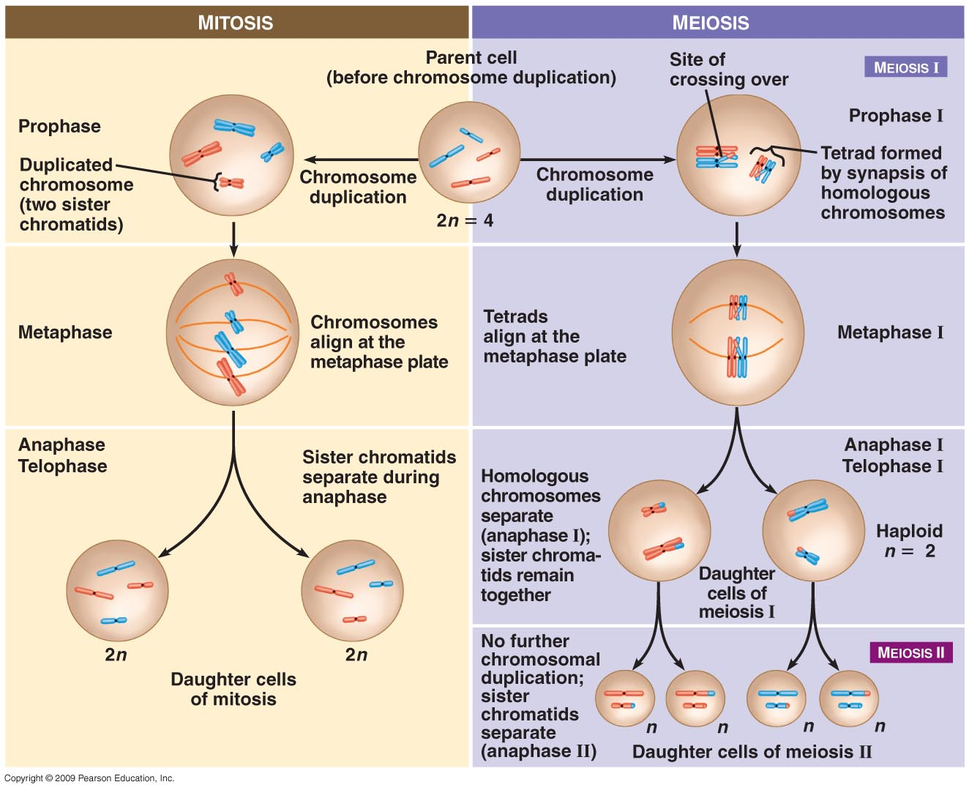

|  |  |  |
| --- | --- | --- |
|  | **Mitosis** | **Meiosis** |
| **Function** | growth and development, repair damaged tissue | sexual reproduction |
| **Type of Organisms That Carry Out Process** |  |  |
| **Location in Body** | all body cells | gametes/sex cells (sperm & egg) |
| **Crossing Over?** | no | yes |
| **Sister Chromatids Separate** |  |  |
| **Change in Chromosome Number** | no change in number of chromosomes | daughter cells have half the regular number found in parent cell |
| **Daughter cells haploid or diploid** | diploid | haploid |
| **Number of Daughter cells Produced** | 2 | 4 |
| **Number of Cell Divisions** | 1 division | 2 divisions |
| **Genetic Makeup of Daughter Cells Compared to Parent Cell** | daughter cells are genetically identical to parent cells | daughter cells are genetically unique from parent cells |